CLUB DRIVE NEWSLETTER EXAMPLE TEXT. PLEASE EDIT AS NECESSARY. PLEASE USE OUR LOGO AND PICTURE ALSO.

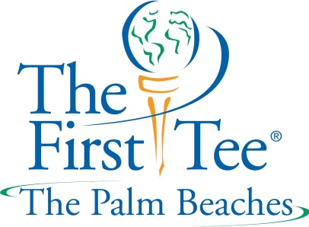

CLUB DRIVE IN PROGRESS

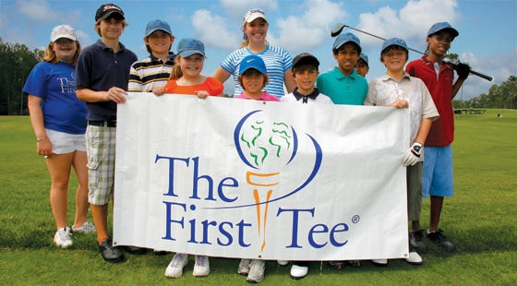
Time to clean out the trunk and the garage and donate all of that unused golf equipment!
We are proud to support our local chapter of The First Tee. Each year, The First Tee of The Palm Beaches reaches thousands of young people in Palm Beach County, including those with special needs, and Veterans. The First Tee is a youth development program that teaches a valuable Life Skills curriculum with golf as the method of delivery.
From February 23rd to March 9th we are conducting a CLUB DRIVE to support the chapter. If you have any clubs, bags, shoes or new clothes that you are not currently using, please consider donating them to The First Tee of The Palm Beaches. Please bring your clubs and bags to the cart staging area and our staff will collect your donations. Your donation is tax deductible and we will give you an IRS receipt letter for your tax return. Thank you for your support!

